**CURRICULUM VITAE**

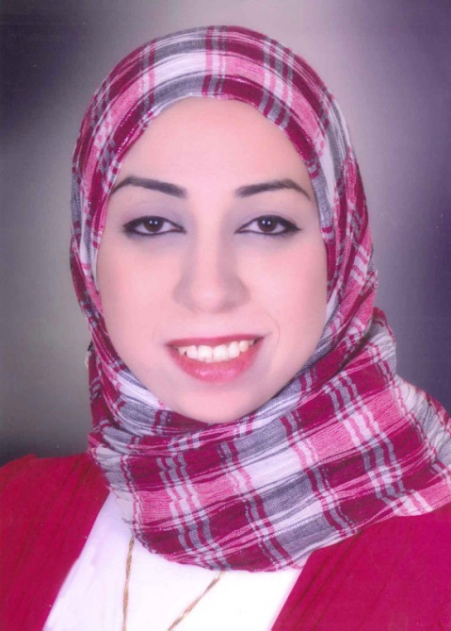**Personal Data:**

**Name :** Wesam Nashat Ali Mohamed

**Gender :** Female

**Date of birth :** 10/04/1978

**Marital status :**  Married.

**Nationality :** Egyptian.

**Address :** Sayd Khashba st.- building no 11 -

Assiut- Egypt.

**Telephone :** Home (+2) 0882298384

Mobile (+2)01002416772

**E-mail address:** [dr.wesamnashat @gmail.com](mailto:wesam%20_nashat@yahoo.com)

**Current Position:**

* Lecturer in Faculty of Medicine, Anaesthesia and ICU Department Assiut University Hospitals – Assiut – Egypt.

**Positions Held :**

* House officer, Assiut University Hospital: March 2002- February 2003.
* Resident of anaesthesia and ICU, Assiut University Hospital: March 2003 – June 2006.
* Assistant Lecturer in anaesthesia and ICU, Assiut University Hospital: June 2006 – October 2013
* Lecturer in anaesthesia and ICU, Assiut University Hospital: October 2013 till now.

**Academic Qualifications:**

* M.B.B.Ch. (very good degree), September 2001, Faculty of Medicine, Assiut University, Assiut-Egypt.
* Master degree (very good degree), April 2006, Faculty of Medicine, Assiut University, Assiut-Egypt.
* M.D degree September 2013, Faculty of Medicine, Assiut University, Assiut-Egypt.

**Professional Registrations:**

* Egyptian Medical Licence (March 2003).
* Member in the Egyptian Medical Syndicate (March 2003).
* Specialist of Anaesthesia at Egyptian Medical Syndicate (November 2006)
* Consultant of Anaesthesia at Egyptian Medical Syndicate ( October 2013)

**Researches:**

* ***M.Sc Thesis:*** "Laryngeal Mask Airway (LMA) versus Endotracheal Tube (ETT) in elective minor surgery during Halothane aneathesia"
* ***MD Thesis:*** "Spinal Lidocaine versus Bupivacaine for short duration operative gynaecological laparoscopy"

**Subspeciality of interest:**

* Obstetric anaesthesia.

**Summary of duties as a specialist in anaesthesia and ICU:**

* Attending five operative schedules per week including all specialities of anaesthesia, supervising residents and under supervision of one of our staff members.
* Attending 10 afternoon and night shifts rotating between the intensive care units (General ICU, Obstetric ICU, Postoperative ICU, and Trauma ICU) and emergency wards (Trauma unit and other surgical emergencies).

**Summary of duties as a consultant in anaesthesia and ICU**

* Consultant of four operative schedules per week including all specialities of anaesthesia, supervising residents and specialists.